Step 1: Publish the project. 1

Step 2: Set up in IIS 1

Step 3: Check app running status by hitting api or UI. 2

Step 4: Start dotcover session with IIS 3

Step 5: Perform Testing 3

Step 6: Stop the session 4

Step 7: Generating Reports and Merging Snapshots 4

### Step 1: Publish the project.

With the below command or from solution explorer, publish the project.

dotnet publish --configuration Release

Ref: <https://learn.microsoft.com/en-us/dotnet/core/tutorials/publishing-with-visual-studio-code?pivots=dotnet-7-0>

<https://www.gearhost.com/documentation/how-to-publish-your-app-from-visual-studio>

Sample Project: <https://github.com/FabianGosebrink/ASPNETCore-WebAPI-Sample>

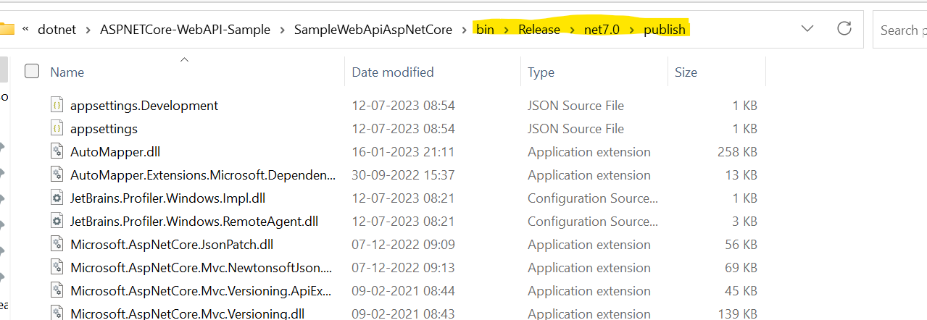

### Step 2: Set up in IIS

Copy the content to a different location to create a website in IIS or directly point the same folder.

Please make sure that folder has sharing rights.

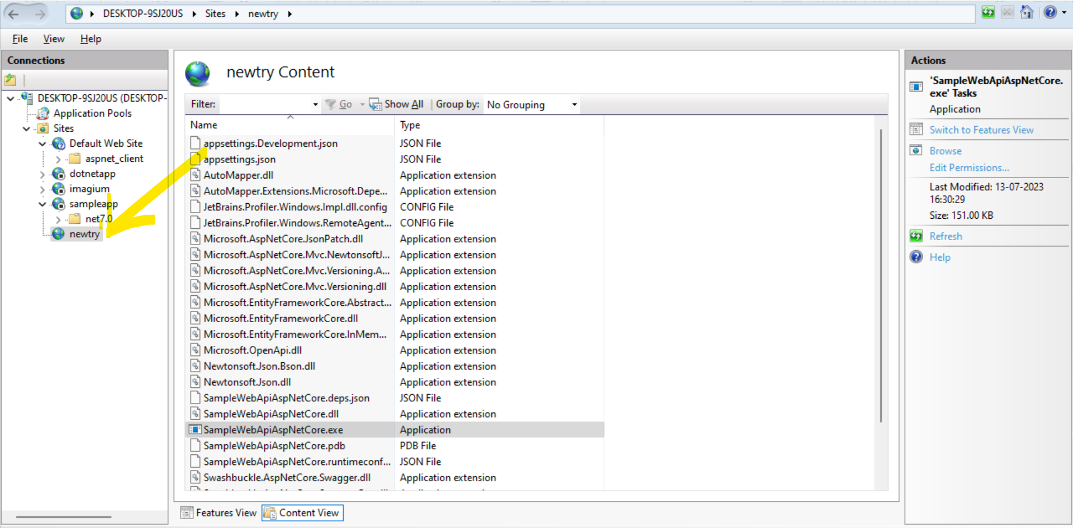

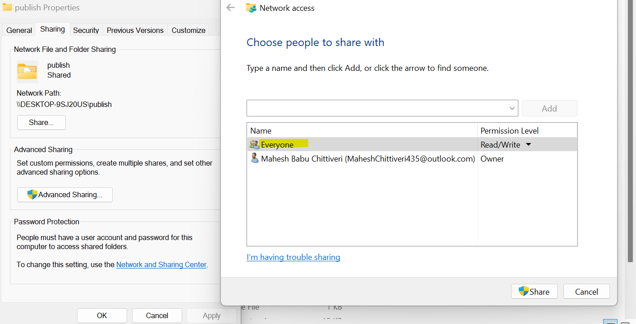

*Without sharing, user will get 500 Internal server error.

### Step 3: Check app running status by hitting api or UI.

Hit the apis and observe the responses. Below are the sample screenshots of the same.

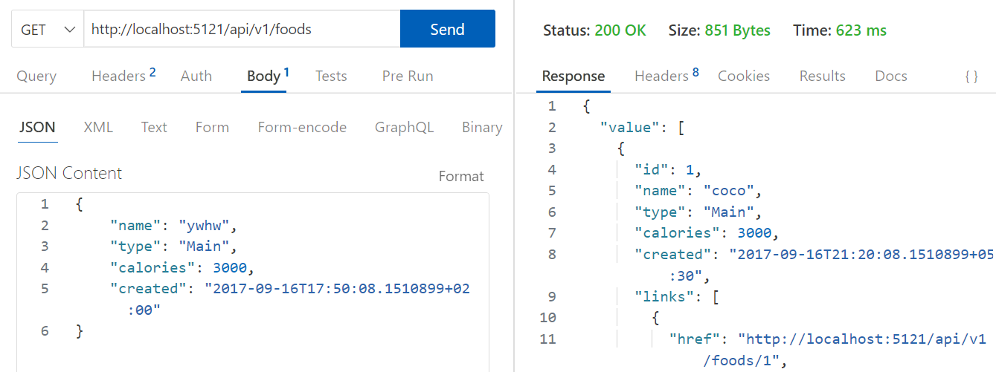

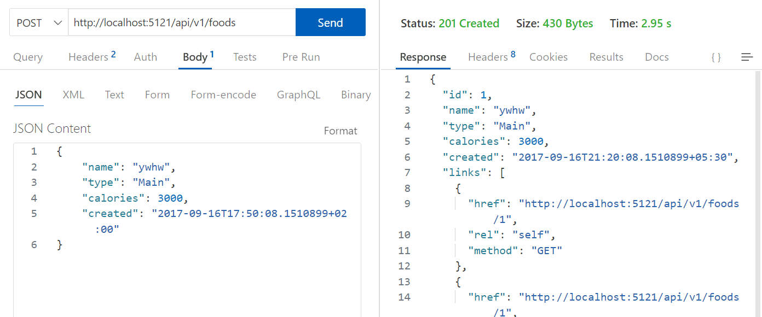

### Step 4: Start dotcover session with IIS

Once ensuring that app is running successfully, start dotcover coverage session with the below command. Inorder to run dotCover.exe commands from anywhere, user needs to add dotcover extracted directory to PATH.

dotCover.exe cover-iis --Output=coverageIIS.xml --ReportType=XML --Instance=1



This will generate report in an xml file. Run below commands for HTML reports

dotCover.exe cover-iis --Output=coverage_one.Html --ReportType=HTML --Instance=1

dotCover.exe cover-iis --Output=coverage_two.Html --ReportType=HTML --Instance=1



Run below commands to generate coverage snapshots.

dotCover.exe cover-iis --Output=snap_one.dcvr --Instance=1

dotCover.exe cover-iis --Output=snap_two.dcvr --Instance=1



### Step 5: Perform Testing

Hit some api and check the responses



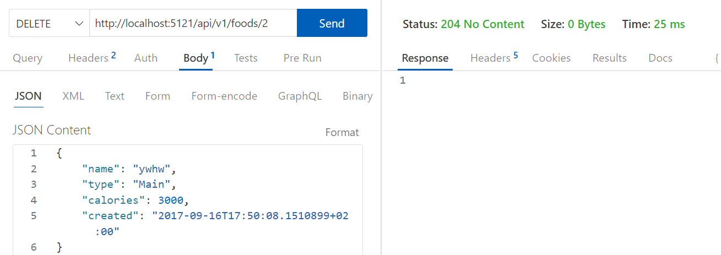

### Step 6: Stop the session

Stop the coverage session by using below command.

dotCover.exe send /Command=GetSnapshotAndKillChildren /Instance=1

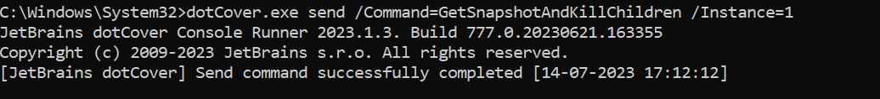

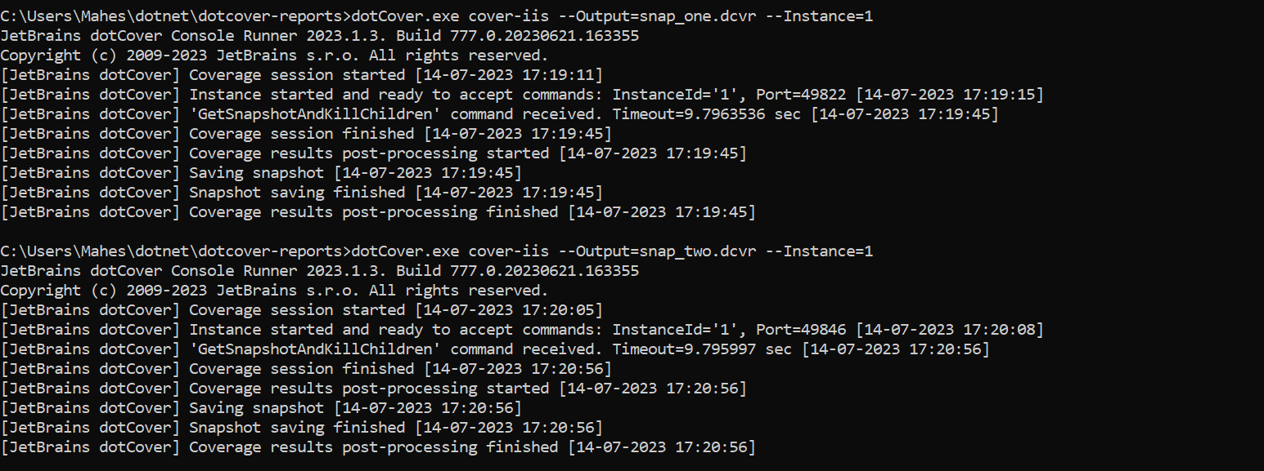

### Step 7: Generating Reports and Merging Snapshots

Merge two snapshots using the below command.

dotCover.exe merge --Source=snap_one.dcvr;snap_two.dcvr --Output=combined.dcvr

Generate HTML report from the snapshot using the below command.

dotCover.exe report --Source=combined.dcvr --Output=generated.Html --ReportType=HTML

dotCover.exe report --Source=snap_one.dcvr --Output=snapGenerated.Html --ReportType=HTML

dotCover.exe report --Source=snap_two.dcvr --Output=snap2Generated.Html --ReportType=HTML

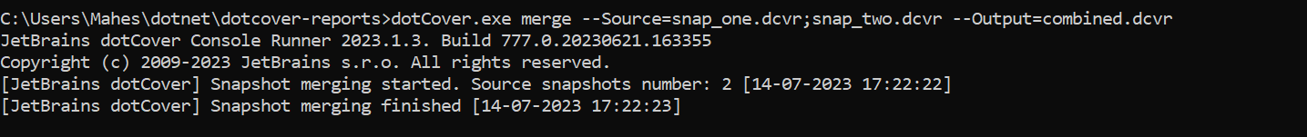

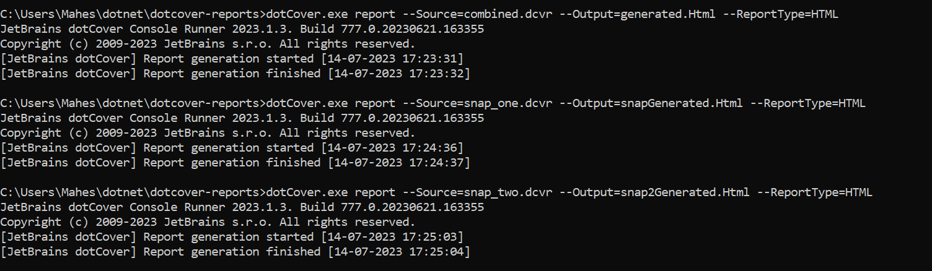

Sample XML report:

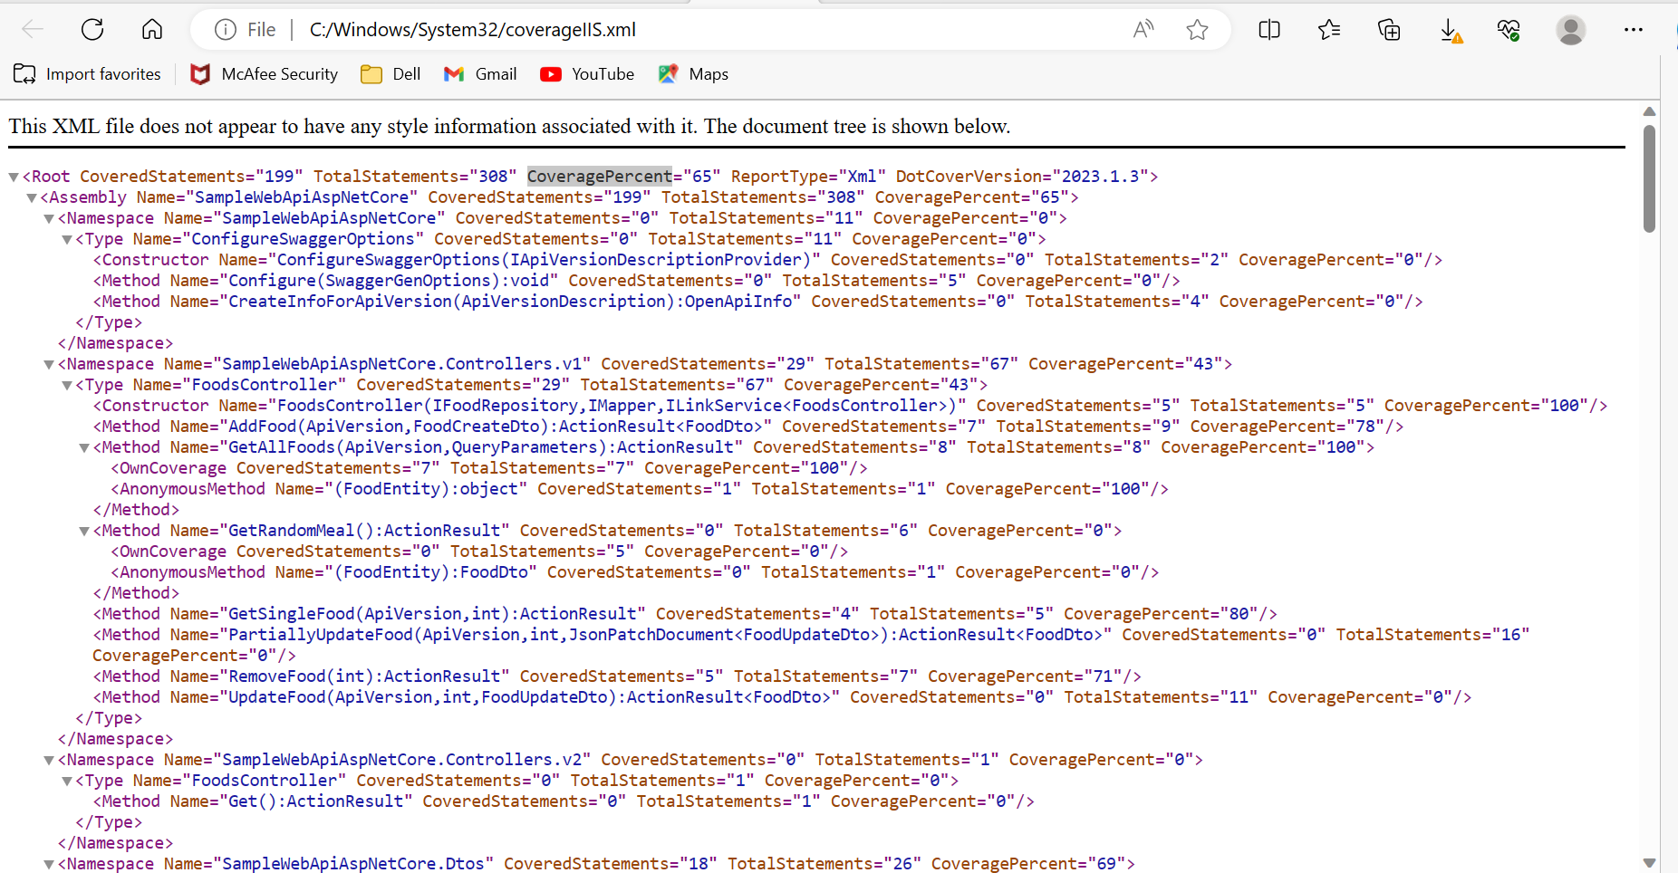

Sample HTML Report:

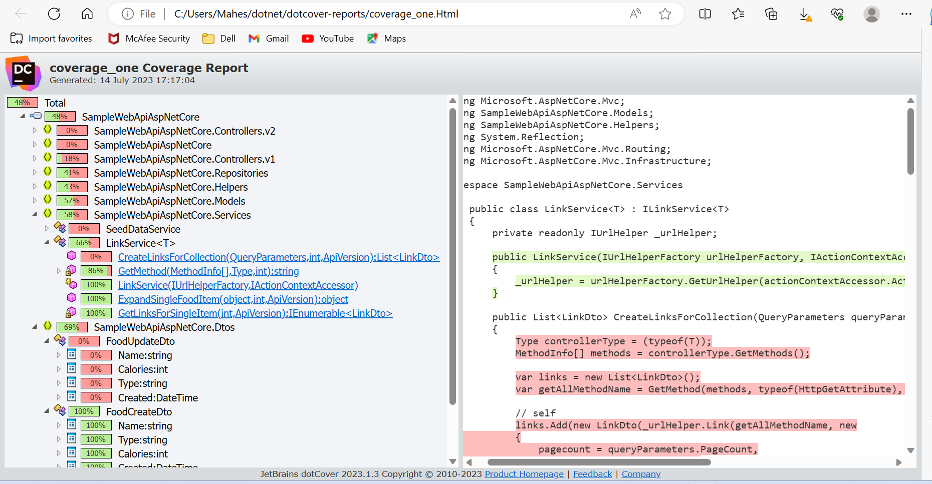

Individual sessions:

Session 1: Generated HTML report from the dcvr snapshot file for session one 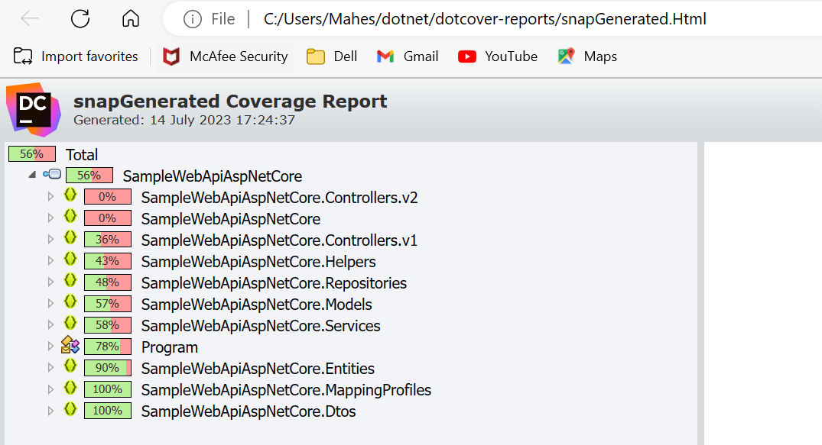

Session 2: Generated HTML report from the dcvr snapshot file for session two

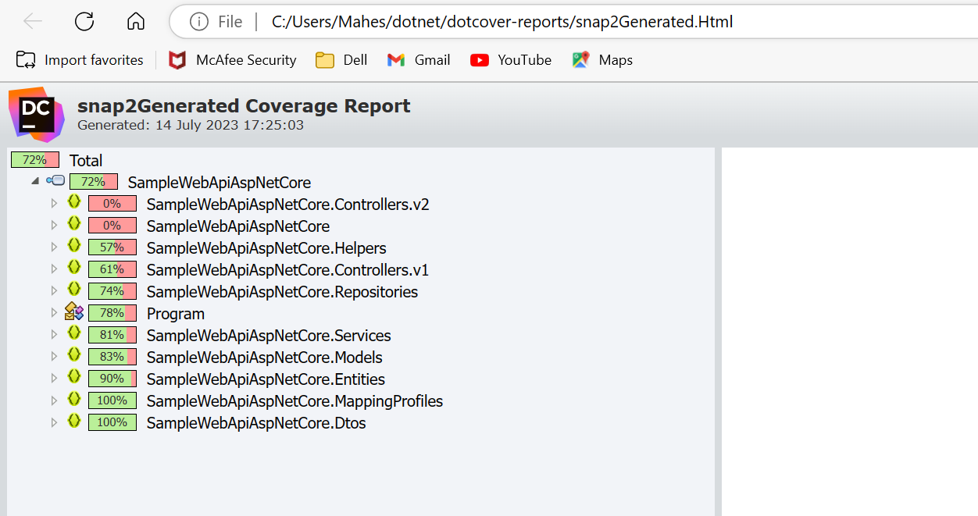

Combined report: Combined both dcvr files and generated HTML report from the combined.dcvr file

